IRISH STUDIES●Spring 2017

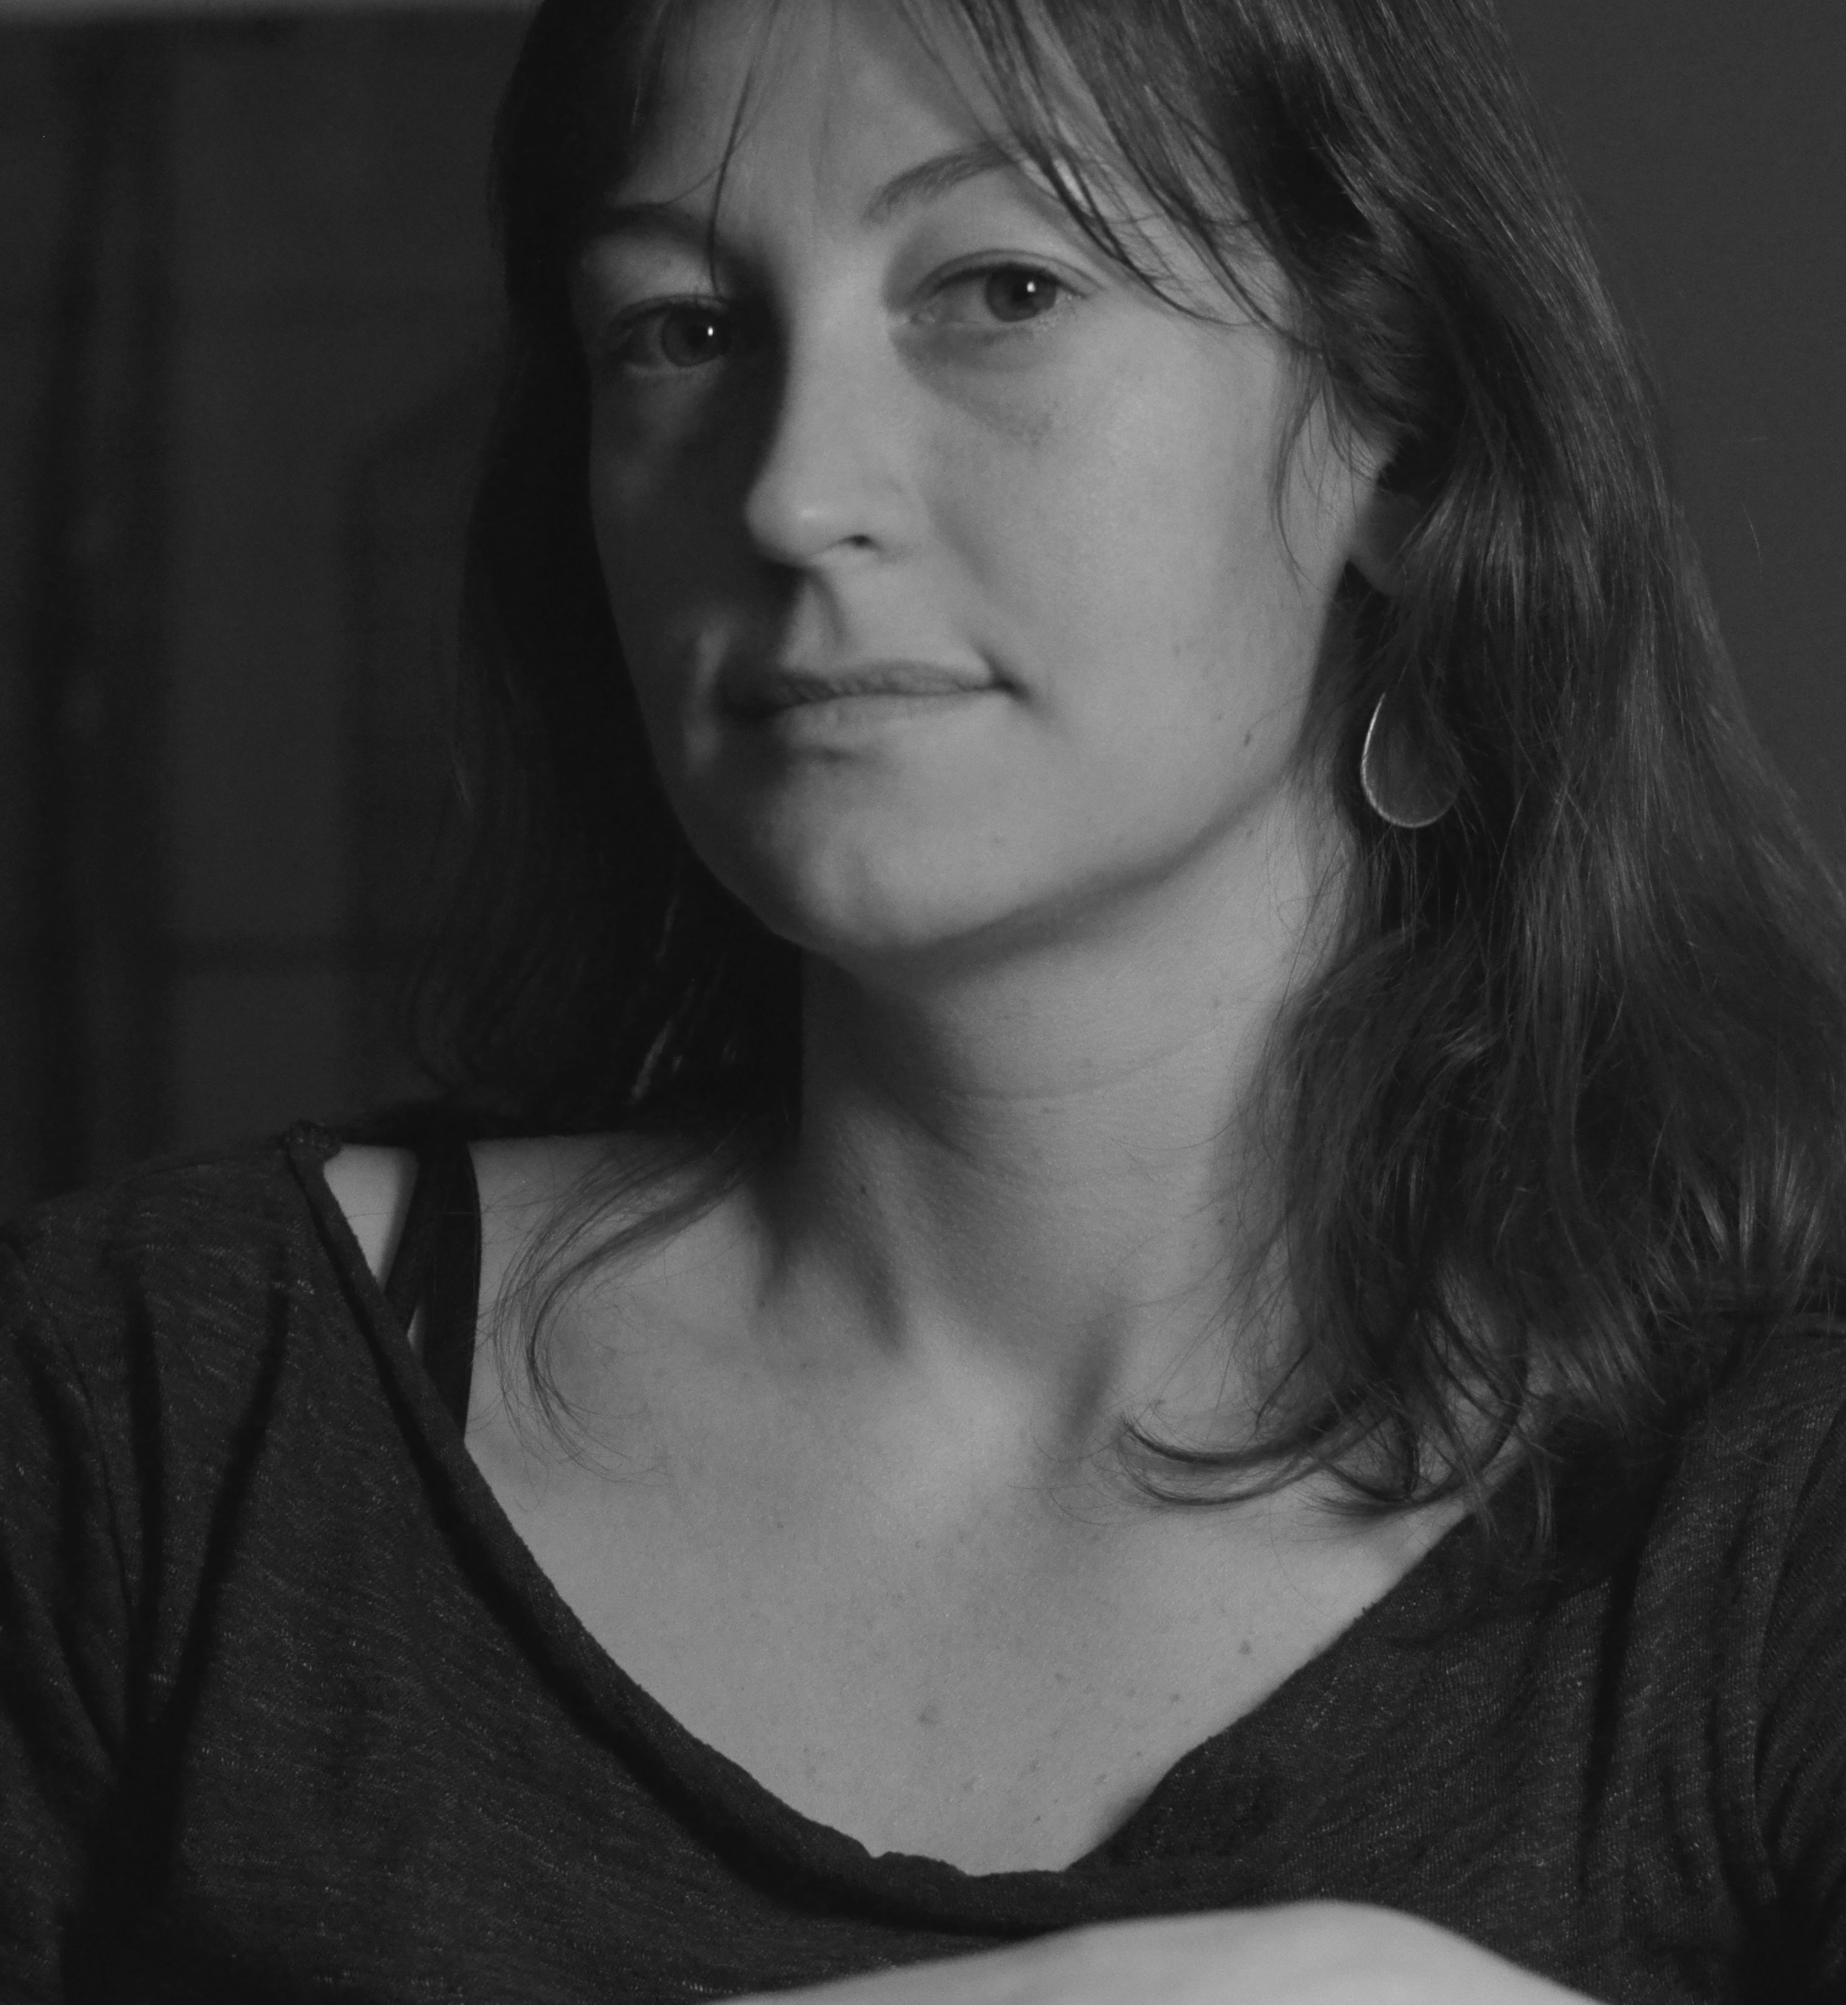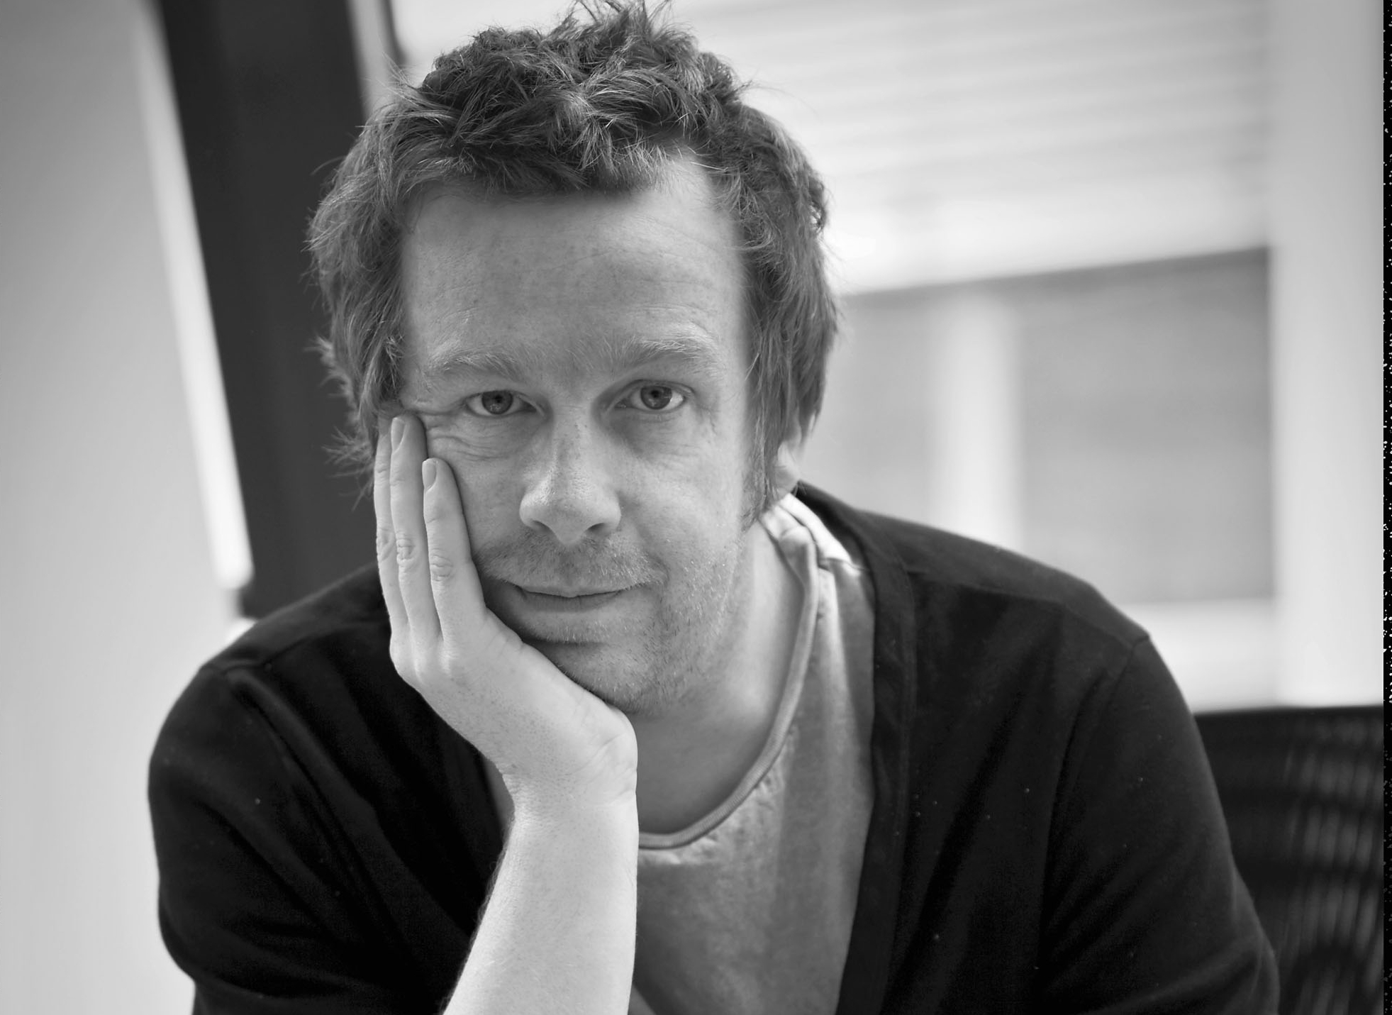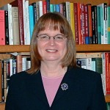

KEVIN BARRY, Gerson Reading 2017
7:00pm April 11 (Tues.), Alumni Center, in honor of Louis Gerson*
Kevin Barry (center) is one of Ireland’s most internationally prominent contemporary fiction writers. His novel City of Bohane, winner of the 2013 International IMPAC Dublin Literary Award, was described by the New York Times as “an extraordinary first novel” exhibiting “marvels of language, invention, and surprise.” His 2015 novel Beatlebone won the 2015 Goldsmiths Prize, awarded to British and Irish fiction that extends the possibilities of the novel. Beatlebone is also a nominee for the 2017 International Dublin Literary Award, the world's most valuable annual literary fiction prize for books published in English. Barry has also published two collections of short stories and is co-editor and co-founder of influential annual Irish literary arts anthology, Winter Papers.
* This year’s reading will commemorate the late Louis Gerson, who died in recent months.

KELLY SULLIVAN, 11:00 am April 13 (Thurs.), BUSN 204
Kelly Sullivan (left) is a poet and fiction writer and Assistant Professor/Faculty Fellow of Irish Studies at NYU with an expertise in Irish late modernism. Her novel, Winter Bayou (2006) was published by Lilliput Press, Dublin, and her poems and short fiction have appeared in Poetry Ireland Review, Salmagundi, The Moth, Southword, The Hopkins Review, and UnderWater New York. She has an MA from University College, Dublin, and a PhD in literature from Boston College. She will read from her poetry chapbook, Fell Year, forthcoming with Green Bottle Press (London) in spring 2017. Her poems engage with questions of private experience and public address, and chart dark pastoral landscapes and experiences of loss through human connections to the environment.

BRENDA MURPHY, 11:00am March 23 (Tues.), BUSN 204
Brenda Murphy (right) is Board of Trustees Distinguished Professor of English Emeritus at UConn. She is the author of twenty books, the most recent being Eugene O’Neill Remembered (2017), a biography in documents. The subject of her talk will be After the Voyage: An Irish American Story (2016), historical fiction based on the experience of her immigrant family in the Boston area from 1870 until the 1930s.

FREE AND OPEN TO ALL
Events co-sponsored by ENGLISH DEPTARTMENT SPEAKER FUND, IRISH STUDIES, and the GERSON FUND
mary.burke@uconn.edu for details

